Project Proposal

On

Grocery store

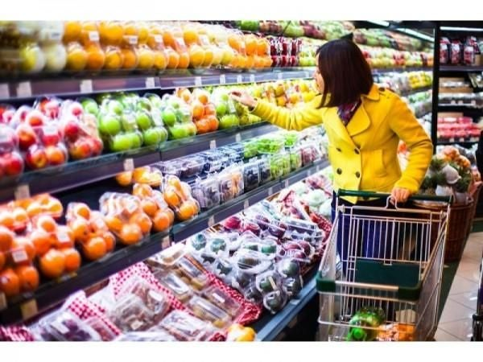

Sahara Magar

Batch: 23’A’

Computing Project

Softwarica College of IT and E-Commerce

Submitted to: Kiran Rana

Contents

**1.Introduction 3**

**2.Justification of the project 3**

**i. Background of the project 3**

**ii. Problem statement 3**

**3.Description of the project 4**

**I. Features of the project 4**

**4.Aims and Objective of the project 5**

**5.Development methodology 5**

**I. Description of the methodology (Waterfall) 5**

**Design pattern 6**

**6.Configuration Management 8**

**7.Prototyping 8**

**8.Conclusion 14**

**9.References 15**

# 1.Introduction

grocery store app is the app which is built for the online shopping of the fruits vegetable and meat etc. This app is built for the easiness of the people. They can install this app and can uses for ordering their groceries by sitting at home or anywhere. We also make it mobile friendly as, users can search for the fresh vegetables and fruits and their details and price are also given with others details. This app makes the busy life style of the people easier which can save time and cost.

# 2.Justification of the project

This project is done for the easiness of the people. This grocery store app is an android application where client can purchase basic food items on the web. Basic food item Products are shown in powerful graphical UI. This framework will resemble a virtual grocery store. Client can choose the item he needs to purchase and the chose item will be added to cart. Cart contains client's name, contact subtleties, item he had chosen and the sum. Client can look for the item through classification like Fruits, Vegetables, and meat and so on.

## Background of the project

As grocery items are the most usable items so this app will help the people to buy any types of grocery items from anywhere. Since this framework is made in android it is effectively accessible in advanced mobile phones. Client who has telephones supporting android can without much of a stretch utilize the application and can purchase their basic food item. There is no requirement for holding up in long line. No need of conveying substantial sacks and

battling with streetcars. Client can buy items sitting at home by review pictures of various basic food items and including shopping basket. (Anon., 2020)

## Problem statement

Many problems where find during the search of the items as the users cannot visually identify if the items are fresh or not. So to solve the problem date of the items brought or manufacture are given in description of the item. Users don’t have to wait in the line for buying the items which can save the times. Online delivery is done so; Users can also make the cash on delivery or card delivery.

Through this app user can easily visit the sites and search for their required items. They can also see offers prices of any items. (Anon., 2020)

# 3.Description of the project

## Features of the project

* Login
* Registration
* Home Page
* Slider
* Products Page by Category
* Search
* Cart Management
* Offers
* Order History

**Welcome form:** Allows the users to view the login and register page. Users have to enter valid phone number, email and OTP code is send to the user’s phone number or email then only after verification users can get access to the page.

**Online booking/payment form:** Allows the users to book the selected items like vegetable, fruits and can make the online payment using debit or credit card. Users can also make the payment after delivery.

**Registration form:** New users can get register by entering their valid name, email address, phone number and gender. They can also get register as they can view their old transaction which helps to keep their record of expenditure.

**Dynamic items search:** Users can search their reliable items by selecting the product name like fruits name or vegetables name types of meat. They can also search by alphabetical order.

**Product detail form:** when users types certain types of product then their details are shown like their actual price, discount price, quantity etc. users can also review the product.

**Product order form:** It includes the cart functionality, payment page, add address etc.

**Profile form:** It includes the users details like their number gender, email address. They are allowed to view their order.

**Contact us:** Allows the users to contact the admin through email address or number. Only Admin Can Add, update and delete blogs with certain tags on the items. Users are controlled or handled by the admin. Unauthorized users are not allowed to buy or booked the items.

# 4.Aims and Objective of the project

Main Aims of this project is to build a grocery app which can helps the users to order the grocery items by sitting anywhere.

The objectives of this project are given bellow;

* Is to provide the proper and updated information about the new and fresh items.
* To Ensure sales floor is adequately stocked, signed, and merchandised to brand presentation.
* To Provide high quality, fashion basics at value for money prices.
* To cut Gas and parking costs.
* To Avoid the line and shop in the comfort of your home.
* To Avoid making multiple tips.
* To analyses the requirement specification of the client.
* To produce the system which helps the client for easy payment through online booking.

# 5.Development methodology

## Description of the methodology (Waterfall)

I have utilized waterfall methodology strategy for this project. As, waterfall utilizes the breaking down, structuring, usage, testing and organization stages this can be finished and can't set aside a more extended effort to complete as time is as of now evaluated for this.

This is the main methodology utilizes in programming advancement. This model is the progression insightful or consecutive model where in the one stage must be done before beginning the other stage.

Right off the bat the necessity is assembled, gathered and recorded. Framework is then structured and model according to the prerequisite. The source code is created utilizing the model, rationale and necessity then the framework is structured in littler part or unit.

Each unit is tested in testing phrase which is known as unit testing. After finishing all the testing of functional and nonfunctional part the system then it is provided to the client in deployment phase. In this project users are unlikely to change their requirement as their requirement is already specified. Once the one phase is completed then we cannot go or make changes to the other phase. (Anon., 2020)

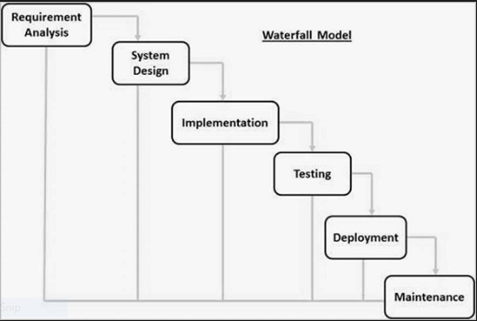

## Design pattern

Design pattern in general is the reusable solution to a commonly occurring problem with in given context in software development. Design pattern Design patterns may be viewed as a structured approach to computer programing.

Design patterns can speed up the development process by providing tested, proven development paradigms. The design pattern that will be using in this project is MVC design pattern. (Anon., 2020)

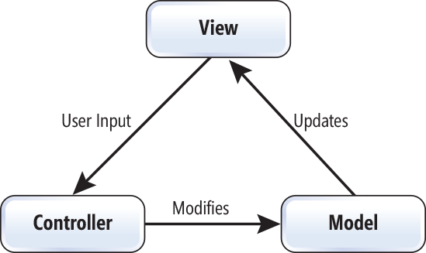

Figure 1 Model View Controller

**Model:**

Model represents the model or shape of the database in which the users works. It also interacts with the database. It also the data been transfer between view and controller.

**View:**

View represent the user interface (UI). It also displays the data with the help of model and also enable or help them to modify the data.

**Controller:**

Controller manage the user’s requests. It acts as the intermediary between view and model in which the incoming request and logic are proceed.

# 6.Configuration Management

CM is the practice of handling changes systematically so that a system maintains it integrity over time. It also refers to the system which track software, hardware and related information of the system. It programs and plans provide technical and administrative direction to the development and implementation of the procedures, functions, services, tools, processes, and resources to develop and support a complex system.

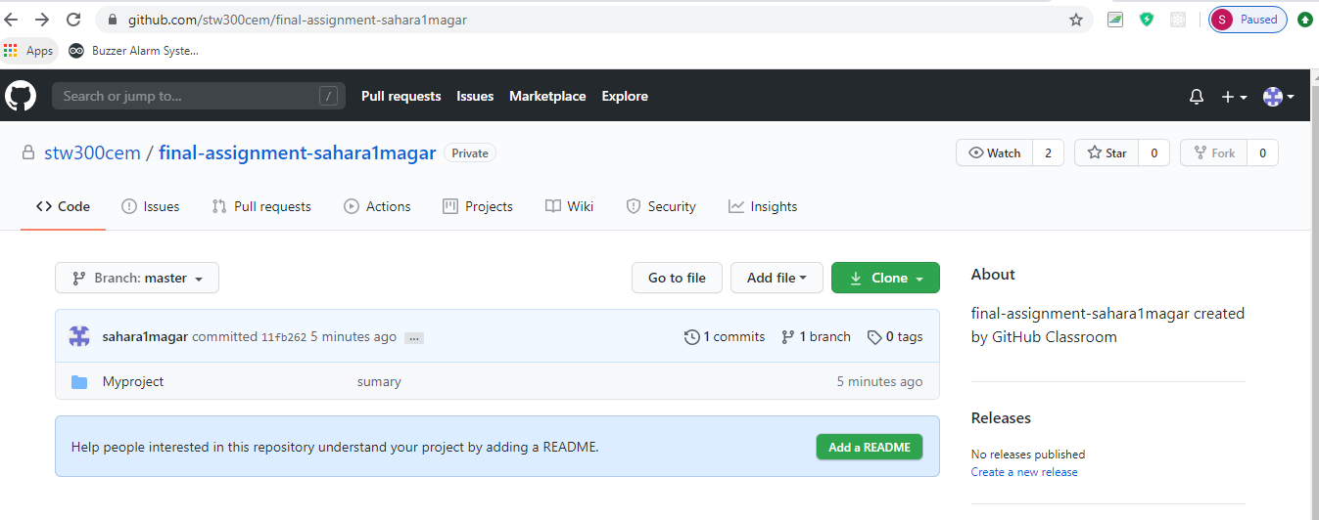

# 7.Prototyping

I have used balsamiq mockup to make the prototype. some of the screen short of my project prototype are shown below;

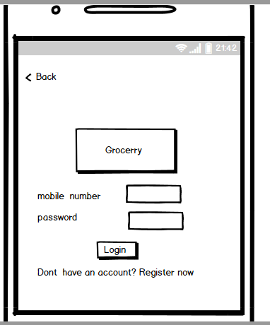

**Figure 2 Login form**

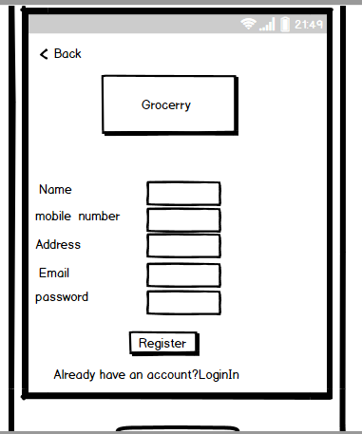

**Figure 3 Registration Form**

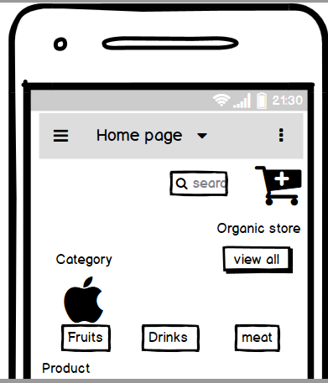

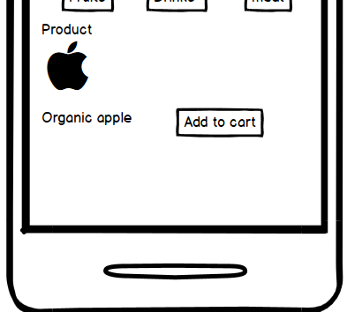

**Figure 4 home page form**

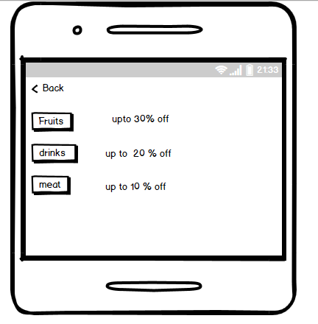

**Figure 5 categories form**

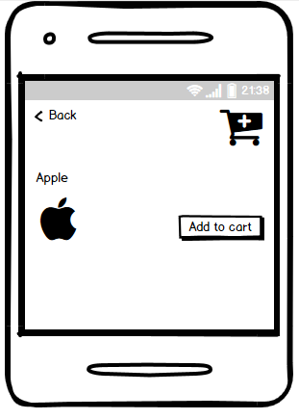

**Figure 6 Product form**

# 8.Conclusion

Grocery app is the user friendly app which allows the users to order any types of grocery items by sitting at home. The users have to first login to make the order. They can view the product categories and select the items and then add to cart which show their total payment amount. With the different types of the features the overview of the project is shown. Waterfall methodology and WBS diagram is also used for the project decomposition.so, this app will help the users who are not willing to visit the mart for shopping which can saves their time and money.

# 9.References

Available at: https://codecanyon.net/item/online-grocey-store-app-grocery-android-ios-app-with-php-cms-backend-restful-api-/23356597  
[Accessed 25 july 2020].

Available at: https://nevonprojects.com/grocery-shopping-android/  
[Accessed 25 june 2020].

Available at: https://www.tutorialspoint.com/sdlc/sdlc_waterfall_model.htm  
[Accessed 25 june 2020].

Available at: https://www.tutorialsteacher.com/mvc/mvc-architecture  
[Accessed 25 june 2020].